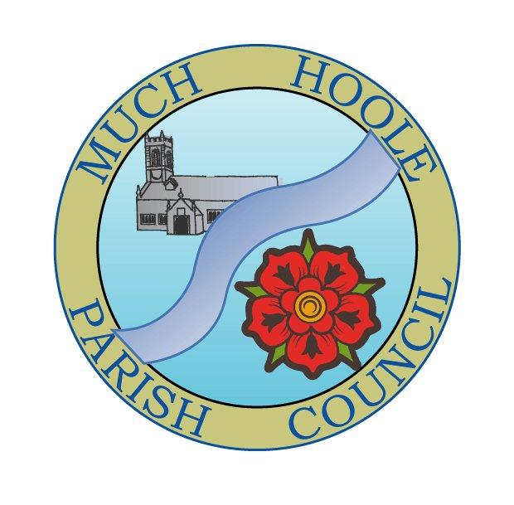 | MUCH HOOLE PARISH COUNCIL  NOTICE OF MEETING
You are hereby summoned to attend the Meeting of Much Hoole Parish Council to be held at 7.30pm on Monday 12th October 2020. The meeting will be held via Zoom video link under emergency powers connected with the Corona virus legislation

Members of the public wishing to ‘attend’ the meeting may do so by applying to the Clerk for zoom login details by emailing him on clerk@muchhoolepc.org.uk

Russ Weaver, Clerk to the Parish Council

AGENDA
1. | Apologies for Absence  To receive apologies for absence.
2. | Declaration of Interests and Dispensations  - To receive declarations of interest from Councillors on items on the agenda  - To receive written requests for dispensations for disclosable pecuniary interests (if any)  - To grant any requests for dispensation as appropriate
3. | Minutes of the Previous Meetings  To resolve to approve as a correct record the Minutes of the Council Meeting held on the 14th September 2020
4. | Public Time  To invite and listen to issues raised by members of the public.
5. | Off Road Cycle Track  To consider any updates on the Cycle track and resolve any actions required.
6. | Village Hall Update  To receive an update on the village hall and plans for its redevelopment
7. | Finance  To resolve to authorise payment of the following:  - To resolve to pay Clerk salary for September in sum of £220.00(net)  - To resolve to pay HMRC PAYE for September 2020 in sum of £55.00  - To note that IT, email and website host fees have risen from £23.00 (plus VAT) to £28.00 (plus VAT). The increased fees are a result of new legislation that require WCAG 2.1 compliance with new standards for public sector websites. The Much Hoole Parish Council website has been re-built to be compliant with the new requirements.
8. | Community led projects  To discuss and update progress on the spending of community funding.  It is proposed to plant winter bedding plants in the planters. No exact costings are available but there are sufficient funds available from within the Lengthsman budget to support the proposal
9. | Planning  There have been no planning applications relevant to Much Hoole since the last meeting.
11. | Local Meetings  .  The LALC AGM will be held by Zoom on Saturday 14th November 2020 at 10.00am. The Council is asked to nominate attendees  It is proposed that Cllr Eunice Houghton and Clerk R Weaver attend the meeting  On 5th October 2020 there was a SRBC Parish Councils liaison meeting. The Clerk attended (via MS Teams video conference link) Minutes of the meeting will be circulated when received. It was noted that Local Area Forum reforms are progressing to improve local consultation
12. | Items for the Next Agenda (for information only)
13. | Date of Next Meeting  The Parish Council to agree the date of the next meeting as 7.30pm Monday 9th November 2020  The format of the meeting will be decided in accordance with Government guidance in force at that time

